Hearing (and Acting Upon) the Voice of the Market
By: R. Eric Reidenbach Ph.D.
Identifying factors that are critical to quality
Successful quality initiatives are based on understanding the true nature of “quality.” It resides in the minds of those who judge it and use it to make their purchase decisions—in other words, the market. Divorced from the market, quality or value has no real meaning. Uninformed definitions of these terms become mere guesses, sometimes right, and many times wrong. The voice of the market (VOM) takes the guess work out of defining quality and helps companies’ direct initiatives to achieve best-in-market results.

Determining CTQ
To identify factors that are critical to quality (CTQ), an organization must first define the products and markets it is targeting. The clearer the definition, the better the understanding of how those products or markets define quality. Unclear definitions result in CTQ factors that are not only fuzzy but also lacking in any practical approach. This makes it harder to put the information to work.
Once the targets are identified, focus groups of buyers within those targets can be convened to identify how buyers define quality and value. These focus groups should be composed not only of the organization’s customers but also customers of its competitors. The output of these focus groups is a set of performance criteria that comprises an overall quality construct.
Identified criteria are then put into a questionnaire that is distributed to current and potential buyers who comprise the targeted product or market. Again, these buyers should include not only the organization’s customers but also the customers of competitors. Respondents are asked to rate the attributes of their supplier’s performance based on a 10-point scale, where 1 equals poor performance and 10 equals excellent performance.
The results from the survey are subjected to a factor analysis to distill the larger set of individual attributes into a smaller set of factors or latent dimensions. These are named based on the nature of their content and become the CTQ factors. They can be prioritized by inserting them into a regression model and generating beta weights for each CTQ factor.
Here is an example of a value model generated from business buyers of wireless telecom services in a regional market. In Six Sigma marketing, the value model is generated during the “measure” stage of the define, measure, analyze, improve, control (DMAIC) method and becomes the information platform that drives the rest of the process. The model ensures that the voice of the market is included in all quality initiatives.
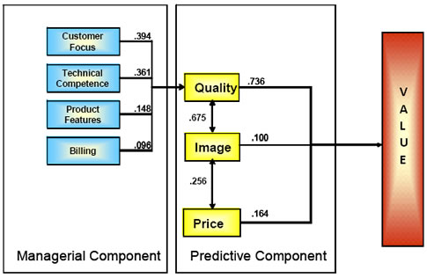
Figure 1: Value model: wireless telecom services/B2B buyers Southeast region

Analyzing the predictive and managerial
The model is comprised of predictive and managerial components. The predictive component identifies the contribution that quality, image, and price make to the market’s understanding of value. In this case, quality (0.736) plays a significantly greater role in defining value than image (0.100) or price (0.164). The numbers between the value drivers (i.e., quality, price, and image) are correlations indicating the degree of association that exists.
On the model’s managerial side are the CTQ factors and their relative effect on quality: customer focus (0.394), technical competence (0.361), product features (0.148), and billing (0.096). Let us look at the most important CTQ factor, customer focus.
The first question that arises is, “What is customer focus?” Suppose your team leader assigned you the task of outlining a plan for improving or enhancing customer focus. Where would you start? The Six Sigma marketing approach provides a detailed blueprint for identifying the people, product, and process options for improving customer focus.
Recall that “customer focus” is a factor or latent dimension. Accordingly, it is comprised of a set of attributes that define it. In this example, factor analysis lumped these attributes into one factor. Based on the nature of the attributes, the team decided to call this CTQ factor “customer focus;” another team may have called it something else. Because of its overall importance in the value model (0.394), customer focus became the primary quality initiative for this organization.
Instead of guessing what customer focus means, the individual attributes provide a clear and direct approach to people, product, and process initiatives for enhancing customer focus.
For example, think of people, products, and processes as Xs. These drive the Ys, which represent actions taken on the attributes that comprise customer focus. Changing the Xs also makes a positive change to the Ys.
The company began by examining its training programs to ensure that customer representatives:
• Are responsive to a customer’s questions and service needs
• Can promptly make changes to service requests
• Can resolve problems the first time a customer calls
• Are accurately representing products and services
• Are providing timely training on how to use products and services
• Have the ability to explain bills in a clear and concise manner

In addition, the company had to examine the processes that support these customer needs. Do processes exist to allow reps to be responsive to a customer’s questions and service needs, make changes to service requests, or resolve problems the first time a customer calls? Are current processes actually inhibiting reps from providing the requisite level of service? Do the processes need to change and improve? Mapping these processes led to options for enhancing the organization’s customer focus.
From a product standpoint, does the company provide business solutions that satisfy the customer’s communication needs? Does the company have a mechanism for assessing customers’ communication needs?
This process is repeated for each of the CTQ factors identified in the value model. Identifying CTQ factors in a market-based manner that eliminate guess work and provide a clear directive toward improvement and enhancement is a fundamental part of Six Sigma marketing. This is a fact-based approach for growing market share by providing targeted products and markets with superior value. Six Sigma marketing provides the customer with a seat at the quality table. After all, they are the ultimate judge of your quality efforts.

